The base class for all the below topics –

1. Copy and paste the content using Appium.

1. To directly open the page of the application.

Step – 1: Open the command prompt and check the list of emulators connected to the android studio.

🡪adb devices

Step – 2: Next type ‘adb shell dumpsys window | find “mCurrentFocus” ‘ in command prompt.

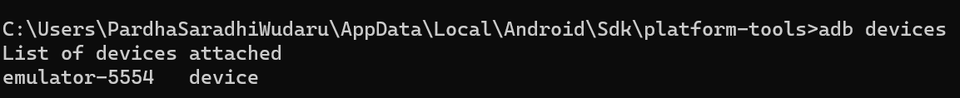



In the second picture, there are package and activity of the application.



1. How to handle Popup notifications using Appium.

1. Drag and drop using Appium.

1. Scroll the page using Appium.

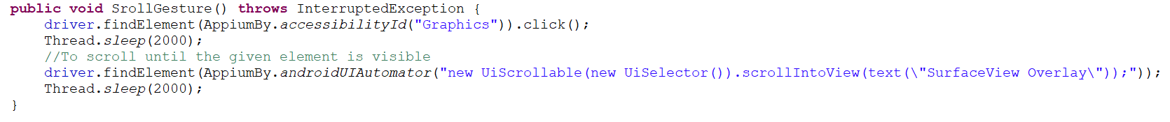

1. How to swipe using Appium.

1. Long press using Appium.

1. To Rotate the screen of virtual device from portrait to landscape.

